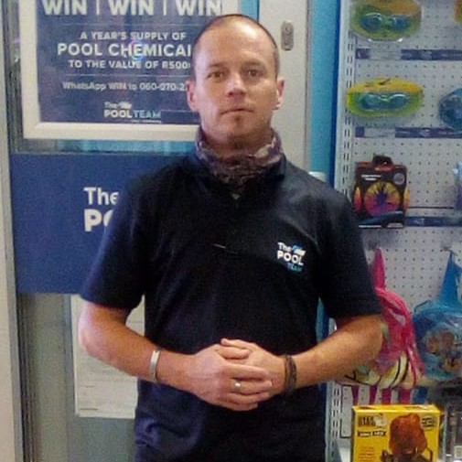
CURRICULUM VITAE

HANS SMAL GUNTER

PERSONAL INFORMATION
Name: Hans Smal
Surname: Gunter
Gender: Male
Race: White
Home language: English
Second language: Afrikaans
Physical address: 22 Darnoc Avenue, Bordeaux, Randburg
I.D number: 790623 5054 088
Driver’s Licence: Code 10 & PDP
Contact number: +27 63 911 4853 or alternative +27 65 530 4841
Availability: Immediately
Profile Summary:
I am a hardworking, honest, diligent and respectful to customers ,employees and my employer.I have accumulated over 13 years experience in the hospitality Industry, so I know all about service with a smile
EDUCATION

Florida Hoerskool, Roodepoort
Matric 1998
Subjects: English, Afrikaans, Biology, History, Typing and Geography

OTHER

First aid, SRQ AMBULANCE School

EMPLOYMENT HISTORY

The Pool Team-Craig hall, Victory Park and Rand Park Ridge (August 2019 to current)
Sales Consultant-Store Manager
Reference: Mathew Manager 082-770-8481

NSA 24(Night shift Auto) (August 2018-July 2019
Co-Owner
Position Co-Owner, assisting company partner with all servicing of vehicles, breakdowns, call outs and maintaining service delivery.
Reason for leaving: company closed down

Night owl catering and Events (January 2017 to May 2018)
Freelance Waitering, video recordings and photography for Church functions and weddings.
Reason for leaving: Part-time position

KES King Edwards School (June 2017 to Jan 2018)
Maintenance-All maintenance work in around school
Reason for leaving: Contract ended with sub contractors

Socialites (Feb 2009 to July 2012)
Sales consultant
Reason for leaving: company closed down
Reference: Madeleine Strydom 084-700-5218

Belem Bakeries Carlton Centre (Jan 2008 to Jan 2009)
Manager-Supervision of all kitchen staff
Reason for leaving: Contract ended

Mikes Kitchen Part own (Oct2006 to Dec 2007)
Senior Manager
Reason for leaving: Better prospects
Reference: Manny (Owner) 011 484-2688

Talisman plant and Tool Hire (January 2006 to October 2006)
Counter Sales Assistant
Reason for leaving: seeking employment in the Hospitality Industry
Reference: James Slatter (Manager) 011 475-4473

Cape Town Fish Market and Sushi bar (Jan 2004 to Dec 2005)
Senior Manager
Reason for leaving: Relocated To Johannesburg

